1. We observed that in the cloned repo, git stores all the git objects in a pack file under .git/objects/pack folder.  
   A screenshot of a computer

   Description automatically generated  
   That pack file is actually archive that saves space.  
   There is one more file parallel to it with extension .idx
2. Let’s try to unpack this pack file.  
   A blue rectangle with white text

   Description automatically generated
3. W have to cut and paste the pack file from .git/objects/pack to .git. Note not copy paste but cut paste otherwise git unpack-objects will not produce unzipping.A screenshot of a computer

   Description automatically generated
4. A screenshot of a computer

   Description automatically generated
5. 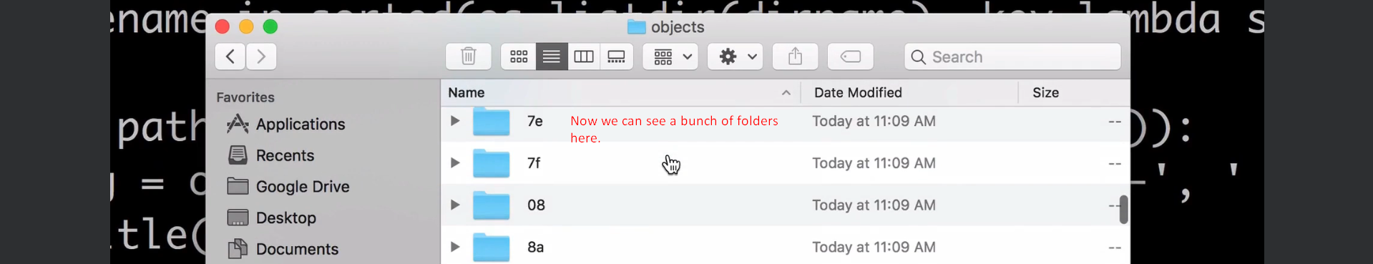
6. A black and white note

   Description automatically generated
7. 
8. A black screen with white text

   Description automatically generated